CEDAR LAKE SUMMERFEST
CARDBOARD BOAT RACE
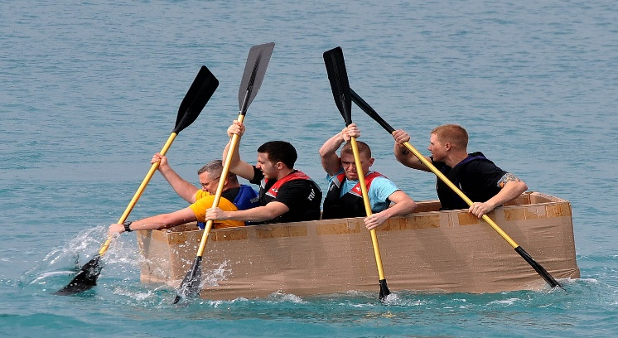
This Photo by Unknown Author is licensed under CC BY
SATURDAY, JULY 1st
TOWN GROUNDS
(In front of the Museum)

CONTEST RULES AND ENTRY FORM

- Boat construction must be primarily of cardboard.
- Other permissible materials include tape, glue, wire, and cloth. Small wood blocking can be used to support propulsion system, ie paddle wheels, sail masts, and rigging.
- Materials that WILL DISQUALIFY THE BOAT include wood as a flotation material, styrofoam (of any type), foam rubber, coatings, balloons, innertubes, water-proofing materials and paint, or any other floatation material or devices, etc. All boats will be inspected prior to the race; VIOLATORS CAN COMPETE BUT WILL NOT BE ELEGIBLE FOR PRIZES.
- Boats can be for a single person or multiple persons, and can be propelled by oars, sails, canoe paddles, or paddle wheel type drive systems (NO MOTOR OF GAS, SOLAR, OR ELECTIC).
- Life jackets must be supplied by and worn by all participants on the boat while in the water.
- Wax as a waterproofing coating is permissible below the waterline. Painting of the boats is allowable above the waterline.
- All participants on the boat in the race must be at least 8 (eight) years of age.
- The course is an oval shape around the two buoys separated by approximately 250 feet. All boats must complete 2 (two) laps to be eligible for awards.
- Boat Participant are encouraged to participate in the July 1st Parade. The parade is immediately prior to the race registration:
- Participants need to make their own arrangements: to enter the Parade (please call Tracy @773-326-5761, go to www.cedarlake.org, or stop by the Chamber Office for an application. Boat race registration begins at 11:00 am the Town Complex.
- Races are by category with three age classes in two division (single and multi-participant)
- The age classes are (8 to 12), (13 to 17), and (18 and up)
- The race begins at 1:00 pm
- The following are the judged events for prizes:
- Best Designed Boat in (All categories)
- Fastest race time on the course in (All categories)
- Most people in the boat (Must remain floating and complete the course laps)
- Anchor (first to sink)
- Participants must remove all sunken or floating materials and debris after each race and dispose of it in the dumpster on lakefront.

REGISTRATION FORM
CONTACT NAME ________________________________PHONE_____________

ADDRESS _________________________________________________________

EMAIL ____________________________________________________________
BOAT CAPTAIN _____________________________________________________
BOAT NAME/NUMBER _______________________________________________

SPONSOR/ORGANIZATION ____________________________________________
PARTICIPANTS NAME AGE
- _____________________________________________________________
- _____________________________________________________________
- _____________________________________________________________
- _____________________________________________________________
- _____________________________________________________________
- _____________________________________________________________
- _____________________________________________________________
- _____________________________________________________________
- _____________________________________________________________
10)_____________________________________________________________
11)_____________________________________________________________
12)_____________________________________________________________
Cost: Race W/O ENTERING PARADE $10.00 PER BOAT
Race ENTERING PARADE $5.00 PER BOAT

SEND: Cedar Lake Summerfest
Attn: Cardboard Boat Chairman
P.O. Boz 188
Cedar Lake, IN 46303
CHECK TROPHY RECEIVED 11 TOTAL
(8 to 12) (13 to 17) (18 and up_
___Best Design ___Best Design ___Best Design
___Best Theme ___Best Theme ___Best Theme
___Fastest Race Time ___Fastest Race Time ___Fastest Race Time
Overall
___Most People ___Anchor

